Free and Fair Election Network
FAFEN Preliminary By-Election Report
(NA-153 By-Election March 17, 2016)

NA-153 Multan VI: Lack of Transparency, Partisan Staff Witnessed in Otherwise Peaceful and Orderly By-election

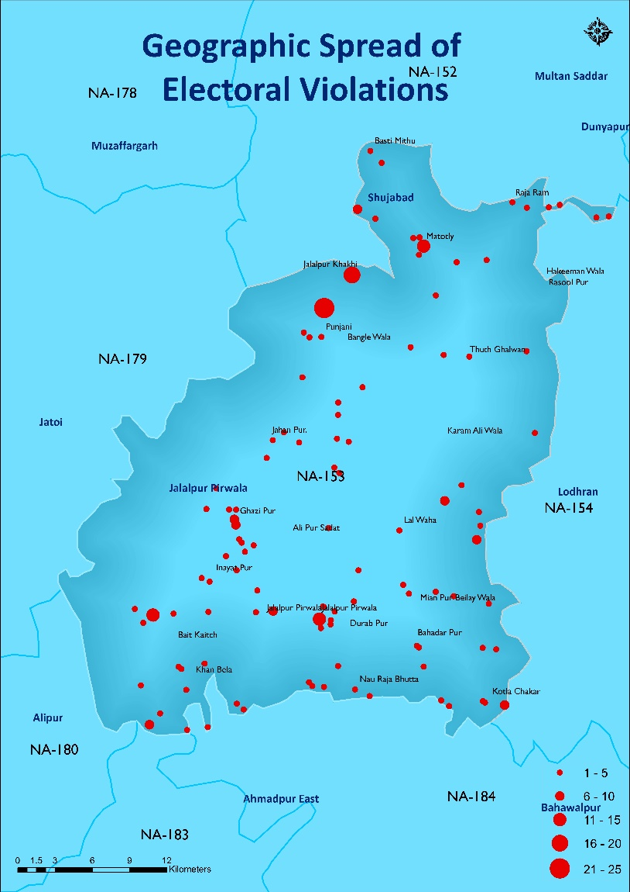
ISLAMABAD, March 17, 2016: The by-election in NA-153 Multan-VI were held in an orderly and peaceful manner, however, issues of insufficient availability of critical election material and polling staff showing bias towards one candidate or party were some of the most common complaints received throughout the Election Day.
FAFEN trained and deployed 70 observers – 48 male and 22 female – in order to observe the opening, polling and closing processes on the Election Day.
FAFEN observers reported a total of 671 irregularities and illegalities from 213 observed polling stations in the constituency – averaging around 3.2 violations per polling station. More than one third of the reported violations were related to the availability of the critical election material with election staff such as officially marked stamps to seal each ballot box from all four sides, Ballot Account Forms and Statements of Count for polling agents of each contesting candidate.
The seat was originally won by PML-N’s Dewan Ashiq who polled 94,298 votes in GE-2013 while PPPP’s Rana Qasim Noon remained the runner-up bagging 88,593 votes. Rana Qasim later filed a petition against PML-N’s Dewan Ashiq for failing to disclose his actual assets and possessing a fake degree. The election tribunal ruled in favour of the petitioner, ordering a re-poll in the constituency, however, PML-N challenged tribunal’s decision in the apex court, which kept up the original decision and ordered re-election in NA-153 Jalalpur Pirwala, a tehsil of Multan.
The by-election was a well-contested competition as 11 validly nominated candidates – seven independent and one each from PML-N, PPPP, PTI and Tameer-e-Nau Pakistan – ran for the seat, but the real contest was witnessed among PML-N, PTI and PPP candidates. However, there was not even a single woman candidate contesting the by-election.
PML-N issued the party ticket to former PPPP candidate and runner-up, Rana Qasim Noon while Dewan Ashiq’s son Dewan Abbas Bukhari was contesting as an independent candidate but withdrew in favour of the PML-N candidate a couple of days before the election. The seat has been won by Dewan family consistently for the past three elections i.e. 2002, 2008 and 2013.
Although the number of registered voters in the constituency has risen up around nine percent in by-election as compared to general election 2013, the number of polling stations set up by the ECP in the constituency has remained the same i.e. 276 (34 male, 34 female, 208 combined). In total, 854 polling booths were established – 450 for male and 404 for female voters.
- Pre-Election Environment
Violations of the Code of Conduct for Political Parties and Contesting Candidates were frequently observed during the pre-election phase as well as the Election Day. FAFEN observed pre-election phase in constituency as well involving interviews from candidates, election administration and observation of electoral environment in accordance with electoral laws and code of conduct. Oversized banners, posters and hoardings were a common sight in the constituency. Candidates and political workers as well as party leaders openly resorted to use of loudspeakers during their corner meetings and rallies. Campaign materials covering roadsides and streets also point towards high election expenses, beyond ECP’s allowed limit. Opposing candidates blamed PML-N’s candidate for promising jobs and political placements in return for vote. Candidates also alleged PML-N of using government machinery such as police and district officials in order to campaign for its candidate.
- Election Day Violations
The Election Day did not go without its share of irregularities and illegalities. Security officials were present inside the polling booths at most of the polling stations and instructing polling staff in discharge of their duties. Polling agents were either made to sit outside the polling booths or at a great distance, preventing them from witnessing the electoral process and, as a result, seriously compromising the transparency of the polling process at such polling stations.
2.1 Campaigning and Canvassing around Polling Stations
Once again, the political parties and the contesting candidates did not pay any heed to ECP’s Code of Conduct and continued canvassing around the polling stations. Party camps were established around 34 of the observed polling stations, of which 24 were issuing serial number slips to the voters. Eighteen of these camps were issuing slips carrying candidate’s election symbol. Armed civilians were seen to be present inside three of these party camps. Candidates openly provided transport to the voters at 74 polling stations.
2.2 Female Voting
At 27 female polling booths, no female polling staff was available to conduct polling. At 17 of these polling booths, some of the female voters left without voting due to unavailability of female polling staff. Unauthorized male were seen loitering inside 18 female polling booths.
2.3 Partisan Polling Staff
FAFEN observers reported 36 incidents of polling staff stamping the ballot paper on voters’ behalf while at one polling station they were seen asking the voters about their voting choice. At 13 polling stations, polling agents were seen stamping the ballots.

2.4 Irregularities in Ballot Processing
A total of 48 complaints were received with regards to irregularities in ballot processing. Of these, there were 30 polling stations where Assistant Presiding Officers (APOs) were not filling the counterfoils in legally prescribed manner before issuing the ballot. At another 15 polling stations, APOs were not stamping and signing the counterfoil.
2.5 Bar on Observation
At 14 polling stations, FAFEN observers were barred from observing the polling process while at another 11 polling stations, they were barred from observing the counting process.
2.6 Suspicious Voting Patterns and Change in Polling Scheme
Keeping in view the vast observation of elections in Pakistan and the international best practices, it takes at least one and a half minute to process one voter at a polling booth. With this rate, not more than 45 voters can vote in an hour. A voting rate greater than 45 voters per hour may, therefore, be termed suspicious. According to FAFEN observers, such suspicious voting patterns were spotted at six polling booths of as many polling stations. There were another 19 polling stations where the census block codes assigned in the final gazetted polling scheme were either changed or the Presiding Officers failed to tell observers as to which census block codes were assigned to their polling stations.
2.7 Unavailability of Critical Election Material
In total, 252 cases of insufficient availability of critical election materials were reported from the observed polling stations. There were 87 polling stations where Form-15 Ballot Account Forms were not available for polling agents of each contesting candidate while at 28 polling stations the Form-14 Statement of the Count was not available for all the polling agents. At another 68 polling stations, four officially marked seals were not available for each ballot box. There were 31 polling stations where the Presiding Officers did not have the polling schemes with them.

